Module 7

7.2 Assignment
Course: CSD325 – 340A
Prepared By: Mirach Erkol and James Buzzell
Date of Report: 11/23/2025

Mikey5007/csd-325: csd-325

7.2 Assignment: Step 1 (city_functions.py)

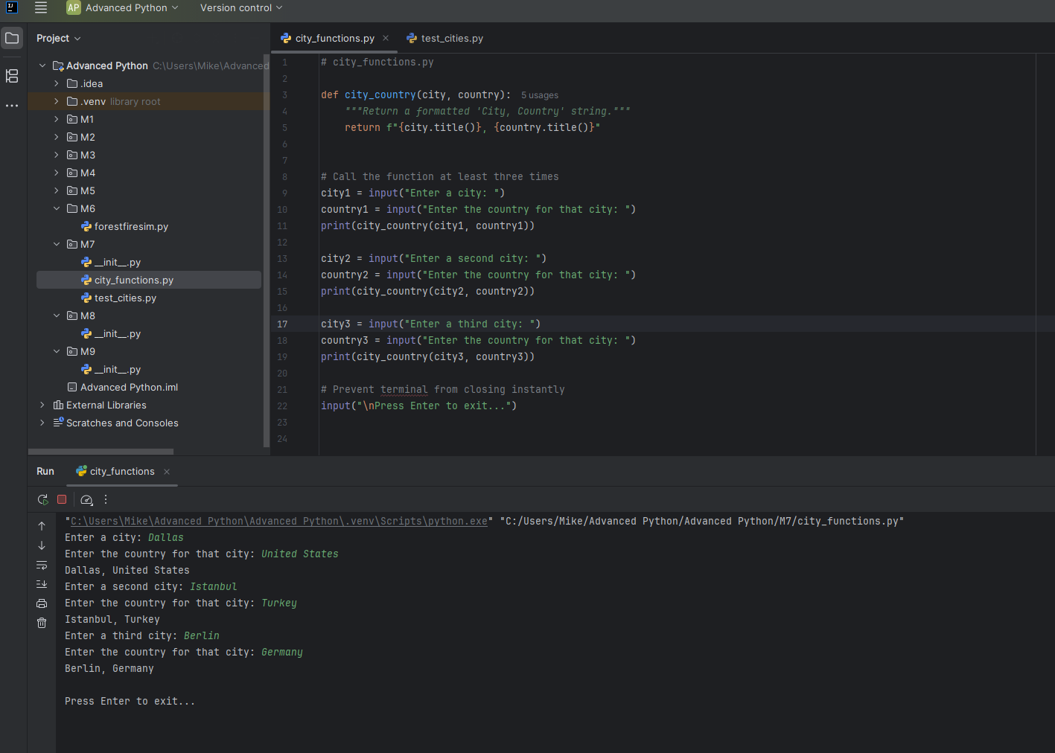
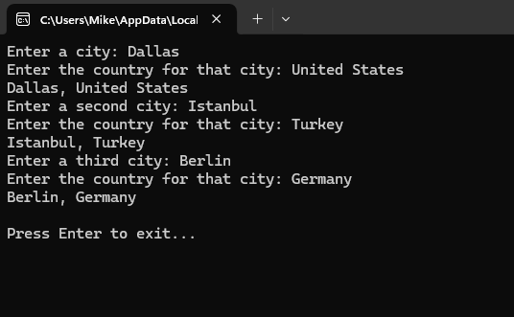

7.2 Assignment: Step 2 (test_cities.py)

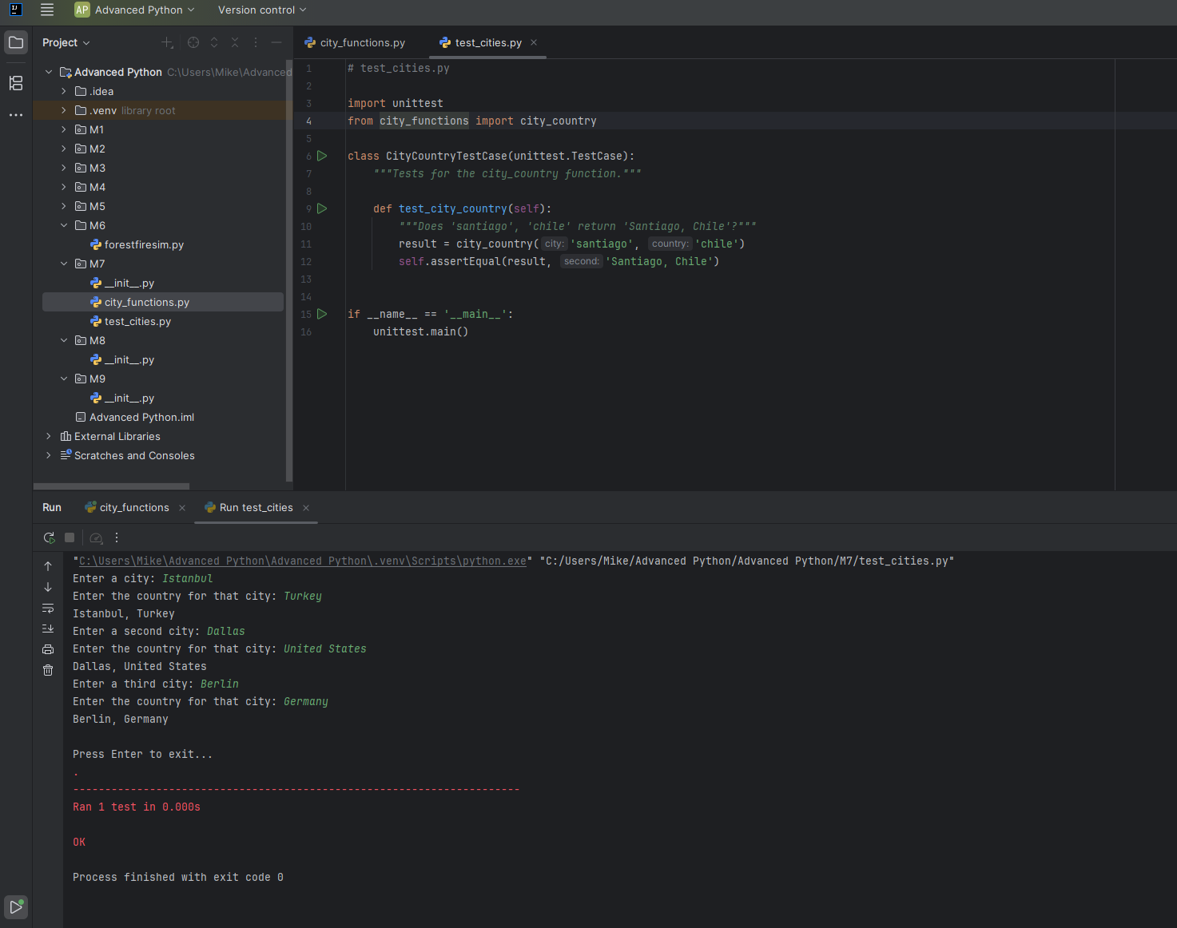
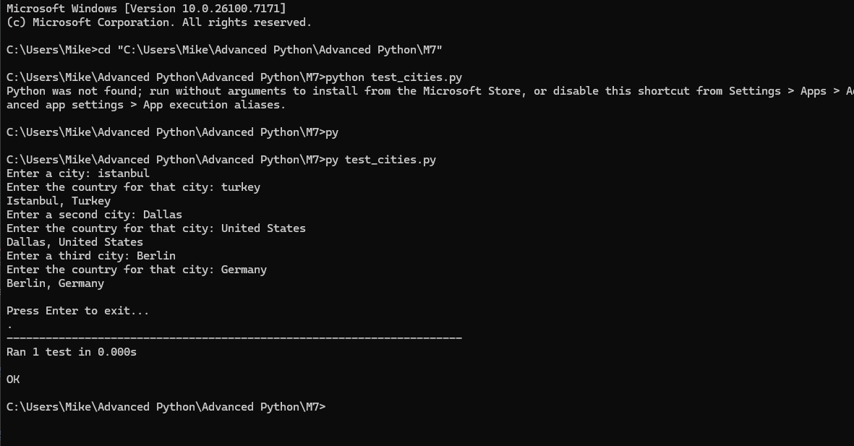

7.2 Assignment: Step 3 (test_cities.py, after modified code for population)
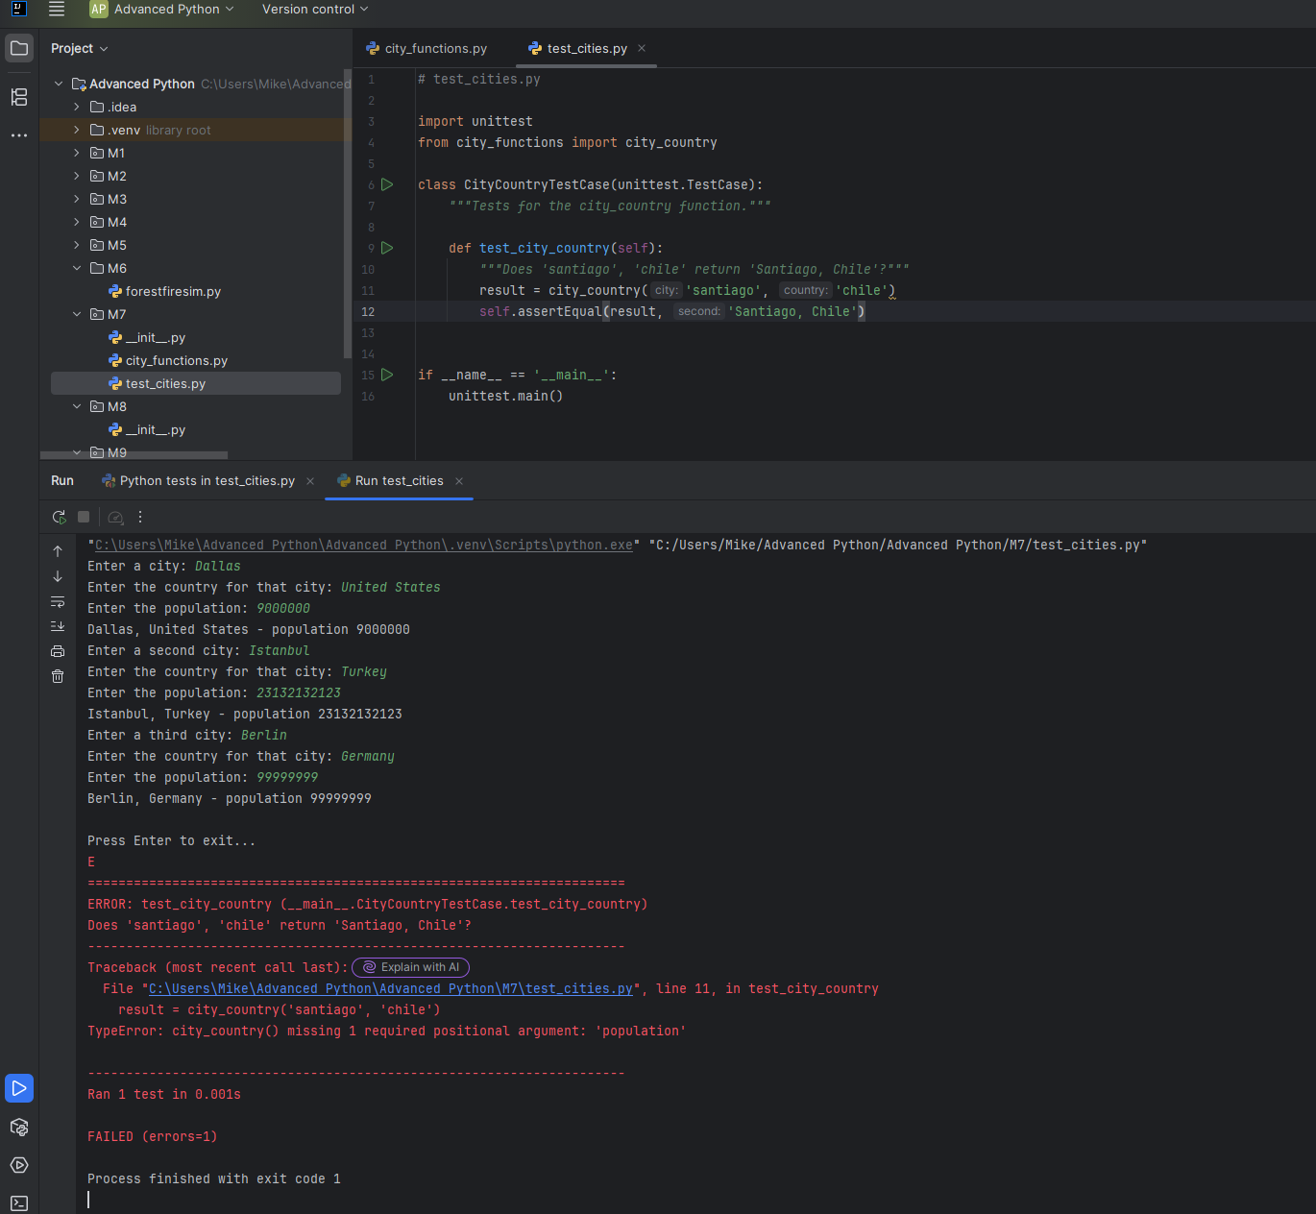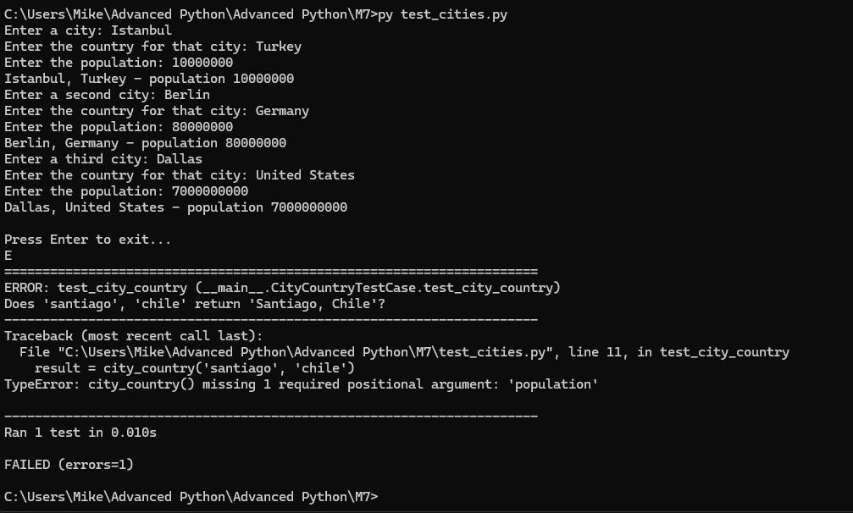

7.2 Assignment: Step 4 (test_cities.py, after modified code for optional population)
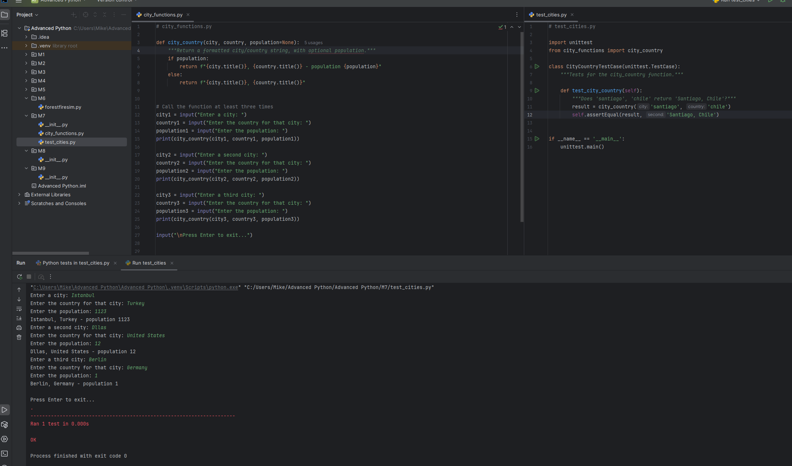
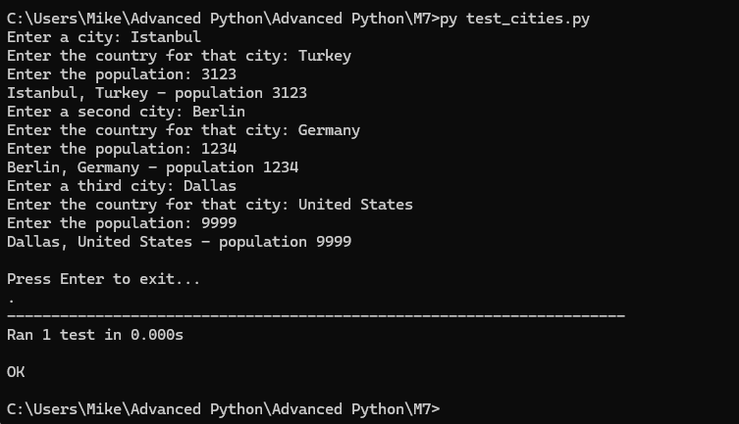

7.2 Assignment: Step 5 (test_cities.py, after modified code for language)
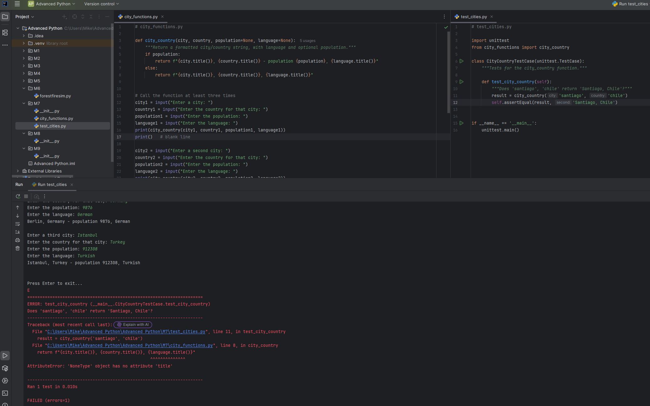
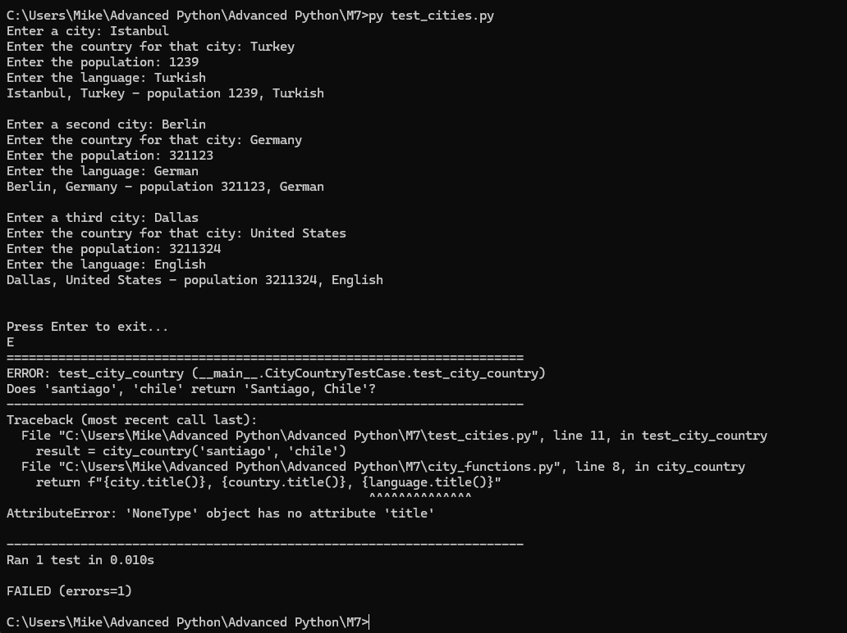

7.2 Assignment: Step 6 (test_cities.py, after modified code for optional language)
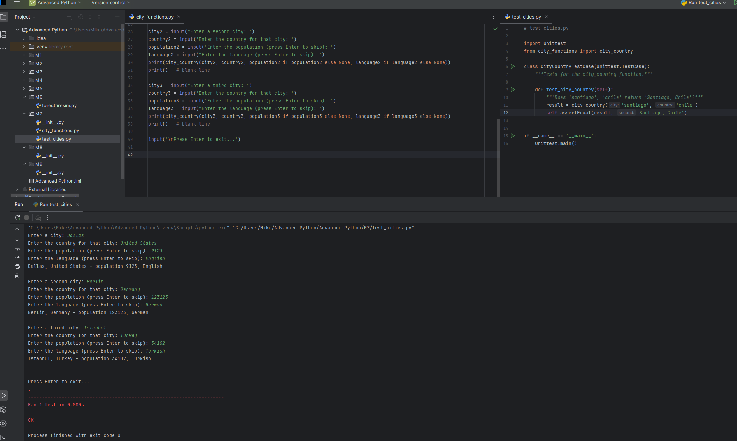
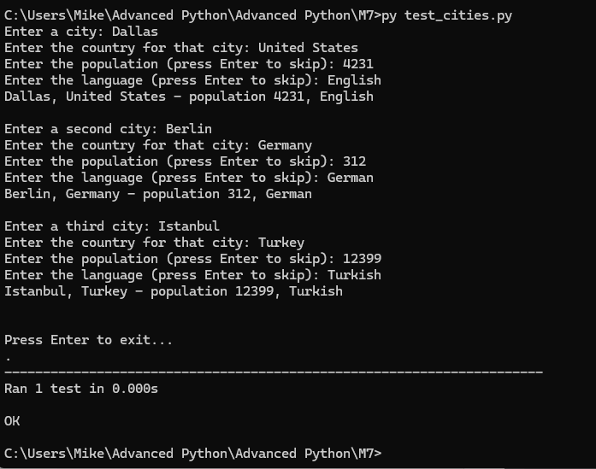

7.2 Assignment: Step 7 (Final version of city_functions.py)

